A Study of High Performance Image Processing in the Browser
Victor O. Santos Uceta¹, Joel Brandt ²
¹ Computer Science Department, Purdue University
305 N. University Street
West Lafayette, IN 47907-2107
¹ vsantosu@purdue.edu
Adobe Inc.
601 Townsend St, San Francisco, CA 94103
² jobrandt@adobe.com

Abstract— This study explores the possibilities of executing complex image processing algorithms inside the browser at high speed. Using experimental technologies/researches and official standards, this study explores the possibilities of moving native high performance image processing software (such as Photoshop) to a web environment by using the heterogeneous resources of modern computing and recent compiling tools.

Recent technologies such as HTML5, WebCL, and LLVM open a world of possibilities to browser’s applications and innovation. All these technologies along with experimental projects such as Emscripten and the Halide Language were explored in combination with commercial browsers (Mozilla, Chrome) in order to implement, benchmark, and analyze different image processing algorithms in the browser.

This study exposes many details of the benchmark implementation and other elements such as code optimization, combination of technologies, JavaScript performance and limitations, viability and risks, security challenges, and code structure’s performance. A set of code snippets, graphs and diagrams are provided to illustrate and explain the different elements of the study. The result of the study is a potential start up point to future research/implementations of high performance image processing by combining these technologies to create pipelines, optimization tools, and experiments in a browser platform.

Keywords- JavaScript, WebCL, Image Processing, Halide Language, Emscripten, LLVM
- Introduction
Cloud computing is a heavily used term in these days. Many tech companies, organizations, and other business are moving their infrastructure to the cloud because of advantages including but not limited to ease of access, flexibility, scalability, cost reduction, agility, and big data.
Small, middle, and large businesses can migrate their operations to the cloud without impact their products and structure. Not everything is so simple in a blooming world of heterogeneous technology; we still have big restrictions on what kind of applications can be ported to the browser. This is due to a countless number of historical events and circumstance that led to the present architecture of computing. The restriction that we will be studying in this paper is the high performance processing in the browser, being more specific: high performance image processing.
- Motivations and goals
In this section we discuss the motivations behind this study and the goals we pursue by analyzing the existing and experimental technologies related to high performance processing in the browser.
- The need for speed
The main motivation of this study is speed. Year after year new technology is created to address the following aspects of in-browser processing:
- Match native computation speed (C/C++ for example)
- Overcome browser’s structural restrictions like concurrency, memory space sharing, and access to low level resources (drivers and system calls)
- Match or overcome native user interface rendering and responsiveness.
Microsoft active X, external plugins, server side processing, browser add-ons, and countless technologies have tried to address these issues yet all falls short or die before reaching the goal. The main two reasons why these technologies have failed are security issues and legacy compatibility, two aspects that are extremely difficult to address.

- Hardware heterogeneity
Mobile devices, cloud based computers (Chrome books), ultra portable laptops, wearable devices (Google glass), and high performance workstations; all these devices have different CPUs, GPUs, peripherals, and connectors supported by different operating systems. This makes the development of applications difficult, time consuming, and costly. The browser in other hand is becoming the universal platform for development without being concerned about the details of the underlying platform.
This abstraction is a double-edged aspect of the browser environment; less detail is less control over the underlying hardware. This is changing over time and more flexibility is being exposed to the developers without violating the security sandbox of the in-browser environment. This is the case of WebGL, a standard for high performance graphics processing in the browser without the need of external components, in other words, the browser is harvesting the power of this hardware heterogeneity.
- Technologies and experiments
In the Table I we present the technologies and experiments involving this study. Some of them are commercial products and others are in early stages of development so can be unstable.
TABLE I
Technologies and experiments
Name | Status | Description
LLVM | Stable | “The LLVM Project is a collection of modular and reusable compiler and toolchain technologies.” [1]
Halide Lang | Stable | “Halide is a new programming language (and compiler) designed to make it easier to write high-performance image processing code on modern machines. “ [8]
Emscripten | Experiment/Stable | “Emscripten is an LLVM-to-JavaScript compiler” [4]
WebCL | Early Stage/In progress | “WebCL 1.0 defines a JavaScript binding to the Khronos OpenCL standard for heterogeneous parallel computing.” [5]
Asm.js | In progress | “A strict subset of JavaScript that can be used as a low-level, efficient target language for compilers.” [2]
Chrome's Native Client (PNaCl) | Stable | “An open-source technology that allows you to build web applications that seamlessly execute native compiled code inside the browser” [1]
River Trail (Parallel JS) | Early Stage/ In Progress | “River Trail gently extends JavaScript with simple deterministic data-parallel constructs that are translated at runtime into a low-level hardware abstraction layer.” [14]
webcl-translator | Early Stage/ In progress | “Webcl-translator is an OpenCL to WebCL converter, it's based on the Emscripten LLVM-to-JavaScript compiler.” [3]

- Harvesting the processing power
The previously presented technologies and experiments will be the base of our study. We will go through each and explore the possibilities of harvesting the processing power and CPUs and GPUs directly from the browser. Once again, our target is image processing, but since we are trying to reach native performance in general, this can be also applied to computations of different nature.
- Technologies evaluation
In this section we evaluate our target technologies and experiments in order to reduce our scope to a specific combination.
- LLVM: We can say that if we are looking for better performance, LLVM is a must in the study. Being the open source treasure of modern compilation, LLVM has been adopted big companies such as Apple for their new language Swift [9]. Also, supports legacy languages such as Ada, Fortran, C/C++, and D.
- Halide: Halide is a very interesting element in our study, a compiler on top of LLVM that ease the creation of image processing algorithms by using a short and abstract syntax. The main features of Halide are parallelism optimization, locality, and vectorization. We decide to use Halide as an optimization platform for our in-browser image processing experiments.
- Emscripten: Being proved of porting high sophisticated code such Unreal Engine [10] to the browser, Emscripten will be used in our study along in combination with Halide and LLVM to execute simple image processing experiments.
- WebCL: WebCL is the browser version of OpenCL bonded to JavaScript. Still in early stages and unstable, but it aims to harvest the heterogeneous processing power of modern hardware. This is exactly what we are looking to accomplish with image processing, so it’s a must in our study.
- Asm.js and PNaCl: These two technologies are trying to accomplish the same goal: better processing performance in the browser. Asm.js is only implemented by Mozilla in their Firefox browser and PNaCl is only supported by Google Chrome. Once again we are facing a race for performance by two big companies. Since PNaCl only works on Chrome by creating a sandbox of native code that can communicate with JavaScript via messages. Asm.js is considered a hack because it uses a subset of the JavaScript language to drastically optimize the performance of the execution. We asm.js for two reasons: its backward compatible and does not require additional code to work like PNaCl. Finally, Emscripten targets asm.js, and there is a large amount of technologies that compiles into JavaScript that can be optimized by targeting asm.js, for example: GWT (Google Web Kit).
7) River Trail (Parallel JS): River trail is the early results of efforts made by Intel and Mozilla in order to bring parallel processing to the browser. It uses OpenCL as an underlying execution platform, but only requires pure JavaScript constructs to implement parallel workflows. Providing the efficiency of WebCL but the simplicity of plain JavaScript, River Trail becomes an important topic in this study.
- Webcl-translator: We will be working with the experimental version of WebCL in the Mozilla’s Firefox browser. Currently, WebCL is only supported via a plugin, but this is expected to change when it becomes a web standard. Webcl-translator takes OpenCL code and compiles the equivalent WebCL version using Emscripten. This tool may be a good experiment target in our study.
- The LLVM experiments
All our target technologies (except WebCL and River Trail) use LLVM for either native compilation or JavaScript/asm.js code generation. For example, in figure 1 we can observe the three forms of an Emscripten code compilation: Native C/C++ code to optimized LLVM bytecode, and finally to JavaScript/asm.js.

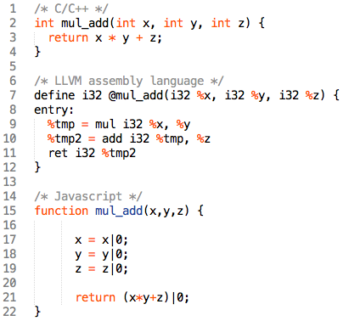
Fig. 1. The three stages of the Emscripten [4] compiler represented in a simple function. Line one: C/C++, line 7: LLVM IR, line 15: asm.js JavaScript code.
  - Emscripten and Halide

We tried to combine Halide and Emscripten. We use one of Halide’s examples (lesson_02_input_image) to create a compilation pipeline that transform that image-processing algorithm into JavaScript/asm.js. There were some problems while trying to create the pipeline; the first one was that Halide works in different ways at the moment of compiling to the target language source (generated code):

- You can use Just In Time compilation (JIT) to execute you abstracted image processing algorithm at runtime.
- Generate the optimized LLVM version of the abstract image processing code.
- Generate the C/C++ optimized version of the provide Halide syntax.
- Generate a machine dependent binary.

Emscripten will generate JavaScript code, so JIT compilation does not make sense in this scenario. We can generate LLVM or C/C++ code and then use Emscripten to generate the JavaScript version of our Halide’s optimized image-processing algorithm.
The resulting JavaScript code is encapsulated in a module that contains the Emscripten runtime. This runtime is the JavaScript version of the C/C++ standard library and emulates the native process stack and heap using the JavaScript typed arrays. The result of asm.js and Emscripten’s runtime combination is an optimized ported code that executes relatively fast. As we know, not all performance improvements are free, all the dependencies of the native code needs to be also ported since no dynamic linking is possible between binary libraries (such as pthreads) and in-browser JavaScript code. The need of compiling dependencies (static libraries) along the desired code, results in large size JavaScript code. The size of the resulting code depends on how large are the dependencies of the code and how are those dependencies used in the code, i.e. include whole namespaces.
For our experiments, two static libraries (libz and libpng) where recompiled to their LLVM versions and then included in the Emscripten compilation along our test code to generate JavaScript code capable of loading PNG images from HTML5 canvas into the Emscripten file system. Note that this file system is an emulation of the C standard library using HTML5 indexedDBs, so if the ported code does some IO, it will be interacting with this virtual-sandboxed file system inside the browser and not with the OS file system.
The result of our experiment was indeed functional; we uploaded an image to the browser, extracted the bytes from the images and wrote a PNG file in the virtual-sandboxed file system inside the browser. At this point the image is ready to be processed by the Halide’s ported code, so we executed the function that reads that image into a Halide’s buffer_t structure (using the ported libpng library), and then executed our image processing function that receives the buffer_t structure pointer as parameter.
After the execution is completed, we extract the bytes of the buffer_t structure back to our HTML5 canvas to obtain our new image.
This is a straightforward technique, but there are some drawbacks and details that must be clarified:
- Since JavaScript is single threaded, Halide’s locality, parallelism, and scheduling cannot be used in the JavaScript environment. With no shared memory space, only web workers with independent memory and no concurrent primitives such as mutexes, monitors, and semaphores, this is the biggest drawback of the Halide + Emscripten combination.
- The generated code is relatively large for a web environment. The ported libpng and libz code size is around 3 Megabytes. This is just using some of the required functions for our experiment; porting the whole libraries will result in larger generated code.
- Glue code is necessary to transfer images between our JavaScript code to the Emscripten generated module. In this case, the glue code is a function returning a pointer and size of the buffer; this is used to read the bytes directly from the Emscripten’s “heap” into the HTML5 canvas buffer.
- Buffers, cloning, pointers, and concurrency
After observing the drawbacks and advantages of using Emscripten, we decided to explore the possibilities of using HTML5’s Web Workers to emulate Halide’s parallelism and scheduling features.
The basic idea is to split the input image into N eight (8) bytes typed arrays with RGBA data as presented in figure 2, then we spawn N Web Workers to process our image processing algorithm in separated threads.

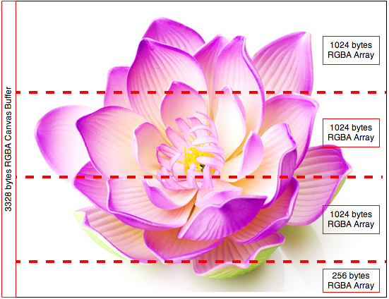
Fig. 2. Graphical representation of an uncompressed PNG image spited into four (4) unsigned eight (8) bytes array with RGBA data.
We found interesting results in the experiment’s behaviour. Unfortunately, in most occasions this is slower than processing the image in the single JavaScript processing thread. There are some details to discuss:
- Buffers: All the processing must be done using typed arrays buffers. Canvas image data is stored in Uint8ClampedArray objects and need to be transferred to the workers. This means that we need to transfer the ownership of these arrays to workers because there is no a shared memory space between JavaScript’s main thread and the Web Workers. Since each worker has its own context, the most efficient way to transfer ownership is using Transferable Objects. Once an object is transferred to a web worker, its automatically neutralized and unusable [11].
- Pointers: At the moment, ownership transfer is the fastest way to send objects to web workers. This works like a C/C++ pointer parameter, no copy of the arrays are created, so it’s really fast to pass arrays of any size without the overhead of object cloning. We need to empathize once again that once the object is transferred, the containing variable in the main JavaScript thread becomes unusable.
- Cloning: Sadly, we still need to clone the arrays. The reason is that if you split a whole array into N new typed arrays by using the subarray method, those new arrays are referencing the original array, these sub arrays are using the same memory but with different boundaries. Changing the content of one array will change the content of the original array. This means that if we transfer one of those arrays, all the arrays pointing to the same area of memory will be neutralized by the transferable objects mechanism. In other words, it’s not possible to transfer references of sub arrays to Web Workers. This constraint forces us to use the method split that clones content of the original array into a new array. The allocation of N arrays is slow, especially when the uncompressed image is large.
- Concurrency: As we mentioned in the previous sections, JavaScript does not provide concurrency primitives, so we need to synchronize the execution of our algorithm using event handlers and a structure that will keep the incoming processed arrays until all the information is received from the workers. Once again, we need to copy the content of the resulting arrays back to the canvas buffer, or allocate a new canvas if the original image needs to be preserved.

The use of Web Workers may sound like a good idea since we need to process independent sections of the image separately. The reality is that the allocation and cloning of big typed arrays makes this process slower than using a single thread to iterate a single contiguous space of memory and apply filters such as gray-scaling or color inversion. This may not be the case of not linear algorithms such as convolution.
- The WebCL experiment
WebCL is currently under development and its only available using a plugin in the Mozilla Firefox web browser, or using custom builds of WebKit [4], or Chromium [12]. By the time this study is being written, WebCL stills in early stage and may cause serious problems such as web browser crashes and even kernel panics. We recommend executing WebCL in a contained environment like a Virtual Machine or on a machine with no valuable data or critical processes.

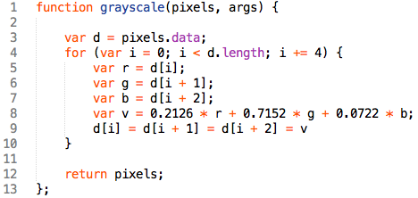
Fig. 3. Source code of a simple gray-scale filter using plain JavaScript and HMTL5 canvas [7].
In figure 3 we have a simple gray-scale filter using plain JavaScript. This function will iterate a canvas image data array and apply the gray-scaling filter to each pixel. The execution of this function is linear with the size of the array buffer. In figure 4 we have a WebCL kernel of the gray-scale filter. The execution of this filter, differs in many ways from the plain JavaScript version:

- The execution of the filter is not single threaded as JavaScript.
- The execution takes place in the WebCL runtime, i.e. out of the JavaScript engine.
- The execution is parallelized according to the resources of the device.
- The execution time still linear for each parallel job, but the total execution time depends on the workload of the resources in which WebCL will execute the filter, i.e. CPU or GPU.
- There is no object cloning in the JavaScript engine. The canvas array data is copied to the device to be executed, or can be accessed directly from the host memory space, i.e. passing the canvas’s buffer pointer to WebCL (memory mapping).

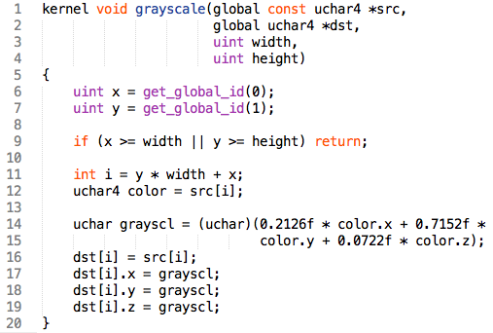
Fig. 4. WebCL’s kernel source code of the gray-scale filter.

Even being in its experimental stage, WebCL’s performance is much better than Web Worker’s and plain JavaScript’s approaches. There is a big difference between the scenarios of OpenCL execution vs. plain C/C++ and WebCL vs. plain JavaScript. In the first scenario, both executions runs natively, so it may be more efficient to execute plain C/C++ code instead of setting up OpenCL instances and contexts. In other hand, there is a big difference between WebCL and plain JavaScript, WebCL executes natively in the device (GPU, CPU), JavaScript executes in the corresponding interpreter engine (Chrome: V8, Firefox: spiderMonkey or asm.js, IE: chakra). In this scenario, WebCL outperforms plain JavaScript for obvious reasons: Concurrency, native execution, and low-level memory management.
- Benchmark
In this section we present the results of a simple benchmark of the three approaches: Plain JavaScript vs. Web Workers vs. WebCL. We executed the same image twice for each data size X algorithm combination. Time is measured in milliseconds, so the lower bars mean better performance.
  - The gray-scale filter benchmark
In figure 5, 6, and 7 we measure the execution times of all three approaches. As we can observe, the smaller the image, the better plain JavaScript performs. The type of algorithm also has to be with the execution time since it’s faster to iterate consecutive allocated memory (array buffers) than compute matrixes.
WebCL and Web Workers are slower because of all the setup necessary to execute the parallel processing routines, in the case of Web Workers the splitting and merging of buffers is the major overhead. It’s important to mention that this benchmark was done using Mozilla Firefox because of the accessibility of WebCL via the experimental plugin [13].

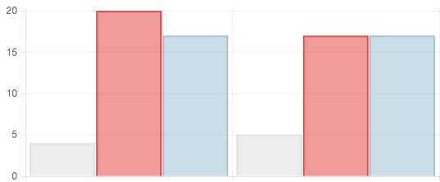
Fig. 5. Benchmark for 771KB of RGBA data (771px. x 600px.), gray-scale filter. Gray: Plain JavaScript, Red: WebCL, Blue: Web Workers. (Lower is better)
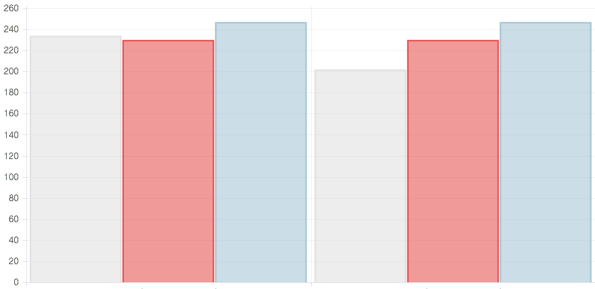
Fig. 6. Benchmark for 38MB of RGBA data (3648px. x 2736px.), gray-scale filter. Gray: Plain JavaScript, Red: WebCL, Blue: Web Workers. (Lower is better)

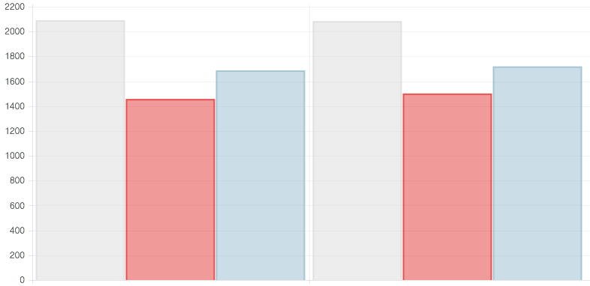
Fig. 7. Benchmark for 269MB of RGBA data (8400px. x 8400px.), gray-scale filter. Gray: Plain JavaScript, Red: WebCL, Blue: Web Workers. (Lower is better)

  - The Gaussian blur filter benchmark
In figure 8, 9, and 10 we can observe the benchmark using the same images as input, but applying a Gaussian blur filter by using a convolution matrix. Once again plain JavaScript performs better in small data, but WebCL is a way faster in the case of large images. In fact, the execution of WebCL is even faster if we pre-process the setup and only benchmark the execution time. In the previous gray-scale benchmark, the resulting times for the pixel processing only (no preparation) were 279ms (plain JavaScript) and 3ms (WebCL). As you can observe, Web Workers were very inefficient for this kind of algorithm.

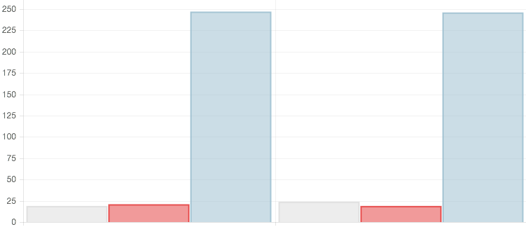
Fig. 8. Benchmark for 771KB of RGBA data (771px. x 600px.), Gaussian blur filter. Gray: Plain JavaScript, Red: WebCL, Blue: Web Workers. (Lower is better)

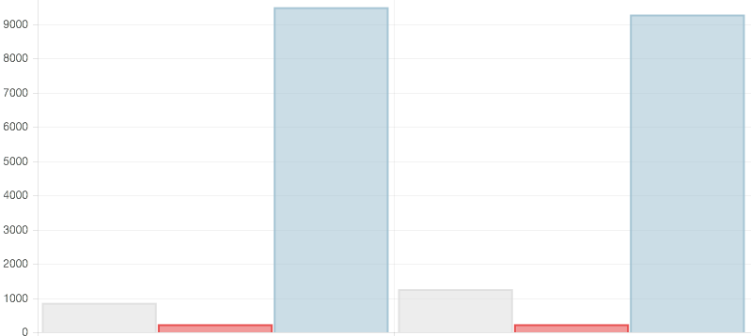
Fig. 9. Benchmark for 269MB of RGBA data (8400px. x 8400px.), Gaussian blur filter. Gray: Plain JavaScript, Red: WebCL, Blue: Web Workers. (Lower is better)

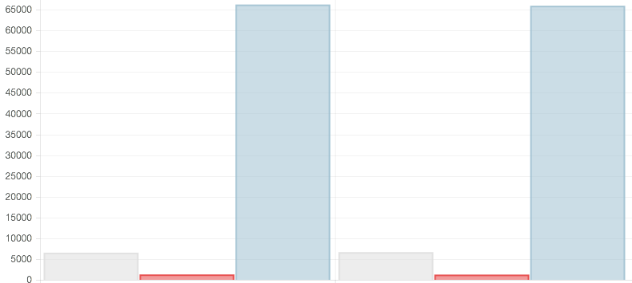
Fig. 10. Benchmark for 269MB of RGBA data (8400px. x 8400px.), Gaussian blur filter. Gray: Plain JavaScript, Red: WebCL, Blue: Web Workers. (Lower is better)

- Conclusion & future work
We study several technologies with the potential of executing high performance image processing in the browser. After testing several combinations, we decided to reduce our scope to three approaches: Plain JavaScript, Web Workers, and WebCL. In general, the most stable and reliable approach is to use plain JavaScript. Even though it does not provide a parallelization mechanism, it’s relatively fast if we measure execution time in the perspective of human perception, i.e. processing relative large images in milliseconds. The Web Workers were created to execute background jobs, but it’s not so efficient to split the image data and join everything in the correct order again. Finally, WebCL looks like a promising technology that when standardized, can finally provide a uniform mechanism for executing intense computations directly in the browser.
  - WebCL and Halide
An interesting future experiment would be to create a Halide pipeline with WebCL. Halide is already targeting OpenCL; in theory it’s possible to port a Halide generated kernel to WebCL. This theory may result in even faster execution because features such as locality, scheduling, and vectorization are present.

  - River Trail
Content Available soon…

Acknowledgment
This study would not be possible without the support of Adobe Inc. We received generous support from the company in terms of technological resources and facilities to execute our experiments. Also, ¹I have greatly benefited from the GEM Consortium and their industry-academy alliance to promote the participation of underrepresented groups. Finally, mentoring given by ²Joel Brandt has been the guiding light in this study; nothing would have been possible without his support.
References
- (2014) The LLVM Compiler Infrastructure Project. [Online]. Available: http://llvm.org
- (2014) Chrome's Native Client. [Online]. Available: https://developer.chrome.com/native-client
- D. Herman et al. (2014) asm.js. [Online]. Available: http://asmjs.org/spec/latest
- A. Liot (2014) webcl-translator. [Online]. Available: https://github.com/wolfviking0/webcl-translator
- A. Zakai (2014) kripken/emscripten. [Online]. Available: https://github.com/kripken/emscripten
- (2014) WebCL: Heterogeneous parallel computing in HTML5 web browsers. [Online]. Available: https://www.khronos.org/webcl
- I. Heikkinen (2014) Image Filters with Canvas. [Online]. Available: http://www.html5rocks.com/en/tutorials/canvas/imagefilters
- (2014) Halide. [Online]. Avalilable: http://halide-lang.org
- (2014) Swift. [Online]. Available: https://developer.apple.com/swift
- Mozilla (2014) Mozilla and Epic Preview Unreal Engine 4 Running in Firefox. [Online]. Available: https://blog.mozilla.org/blog/2014/03/12/mozilla-and-epic-preview-unreal-engine-4-running-in-firefox/
- (2014) Transferable Objects. [Online]. Available: http://www.w3.org/html/wg/drafts/html/master/infrastructure.html#transferable-objects
- (2014) Chromium-WebCL. [Online]. Available: https://github.com/amd/Chromium-WebCL
- (2014) Parallel Computing on the Web. [Online]. Available: http://webcl.nokiaresearch.com/
- (2014) River Trail [online]. Available: https://github.com/RiverTrail/RiverTrail/wiki

